


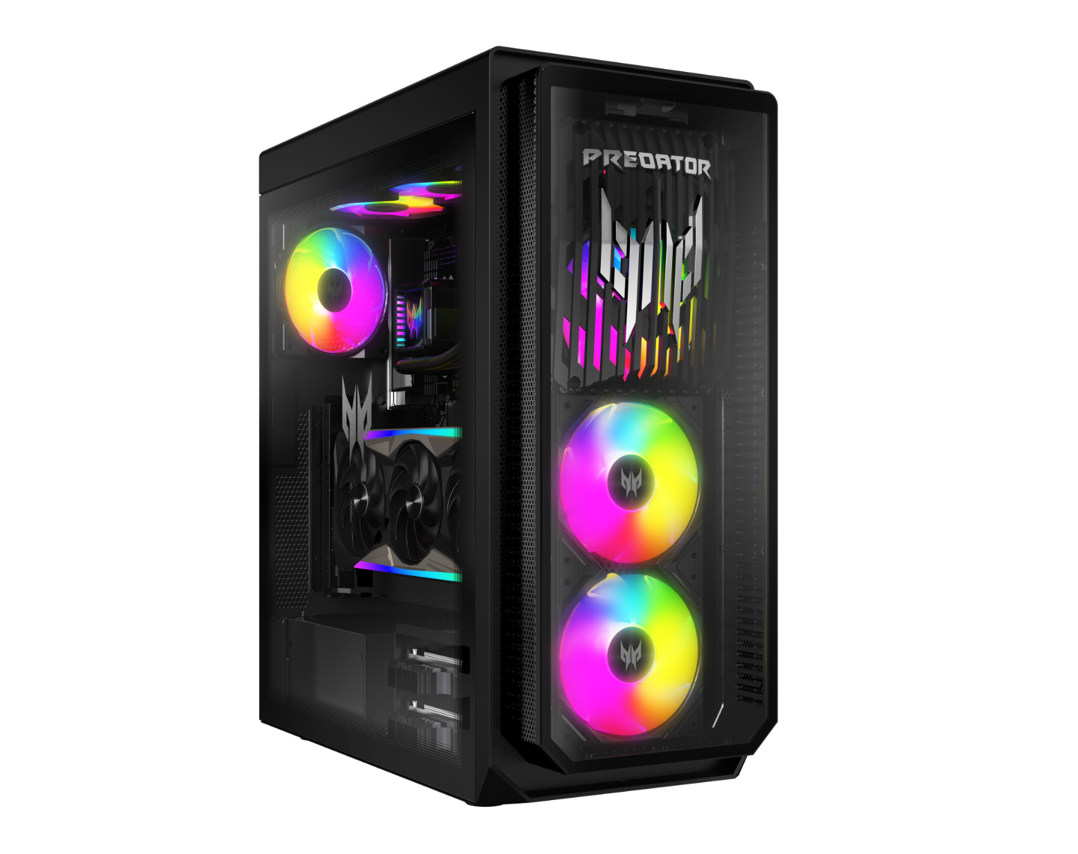

PREDATOR ORION 7000
SPECIFICATIONS PREDATOR ORION 7000 PO7-660
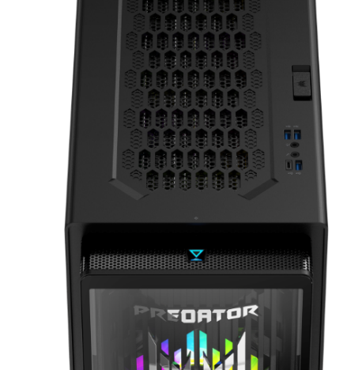
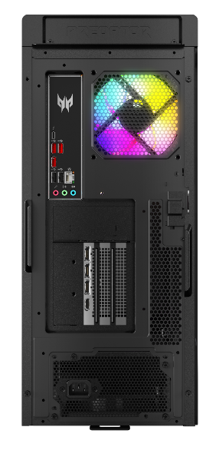
6
5
4
3
2
1
11
12
10
9
8
7
Product views | - M.2 SSD Hot Swap Bay  - Two USB 3.2 Gen 1 (5 Gbps) Type-A ports  - Headset/Microphone jacks  - USB 3.2 Gen 1 (5 Gbps)  Type-A port | - USB 3.2 Gen 1 (5 Gbps)  Type-CTM port  - Power button  - Thunderbolt™ 4 Type-CTM port  - Three USB 3.2 Gen 2 (10 Gbps) Type-A ports |  |  | - Two USB 2.0 (480 Mbps) Type-A ports  - Audio jacks  - Power connector  - Ethernet (RJ-45) port
Operating system^{1, 2} | Windows 11 Home 64-bit.
CPU and chipset¹ | Intel® Core™ Ultra 9 processor 285K  Chipset: Intel® Z890 Chipset  (Notice: The device is compatible with Thunderbolt™ data while using Intel KF series processor.)
Memory^{1, 3, 4} | 32 GB DDR5 5600 MHz RGB  Up to 128 GB of Dual-channel DDR5 4400 MHz
Storage^{1, 5} | Hard disk drive  - 1024 GB M.2 2280 PCI-e Gen4 SSD
Graphics⁶ | NVIDIA® GeForce RTX™ 5090 with 32 GB of GDDR7
Audio | DTS:X® Ultra
Communication⁷ | WLAN  - 802.11ax/ac/a/b/g/n, Wi-Fi 6E and Bluetooth® 5.3
Expansion slot(s) | M.2 slot (for SSD): 3  M.2 slot (for WLAN): 1 |  |  | PCIe x16 slot(s): 1
Windows Desktop Apps⁸ | In-House  - Acer Care Center  - Acer Product Registration  - Acer User Experience Program Framework  - Quick Access  - Storage Utilities |  |  | Search  - PredatorSense V4  Games  - PLANET9 Stub  Lifestyle  - Intel® Unison™  - Acer Intelligence Space
Dimensions | 219 (W) x 504.8 (D) x 485 (H) mm (8.62 x 19.87 x 19.09 inches)
Power supply and adapter | Power supply  - 1200 W, 80 PLUS Platinum, ATX
System compliance | RoHS
Options and accessories | USB keyboard and mouse
Certification | BSMI, CE, FCC, CB
- Specifications vary depending on model.  - 64-bit software is required to enjoy the advantages of 64-bit processing.  - A 64-bit operating system is required to enjoy the ultimate performance of 4 GB or higher memory.  - Memory speed may vary, depending on the CPU, chipset or memory fitted.  - 1 GB is 1 billion bytes, Actual formatted capacity is less and may vary depending on preloaded materials and operating environment. Recovery Management uses a portion of the stated hard disk capacity as dedicated backup space. |  |  | - Total available graphics memory comprises dedicated video memory, system memory, and shared system memory. This figure will vary depending on system memory, installed drivers, BIOS settings and other factors.  - The wireless frequency bands vary across different countries. Actual performance may differ based on national frequency regulations and legal requirements.  - Bundled software may vary depending on hardware configuration, OS and regional availability.

