macOS Catalina 10.15: Screen Recording permission
macOS Catalina 10.15 requires the user to permit "Screen Recording" in order for DisplayLink devices to work properly. The message is generated by the OS and the screen is not actually being recorded by DisplayLink. Approving it enables the DisplayLink driver to access the pixels it needs to render a mirrored or extended screens, and send the pixels over USB from your computer to the DisplayLink display. It does not send any data or pixels back to DisplayLink.
To approve the permission, please follow these steps:
1. Download and install the latest DisplayLink Mac OS release for 10.15.
2. Reboot your system.

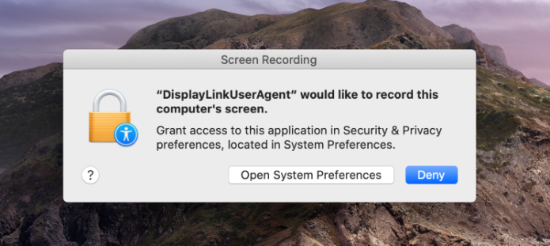
3. Open System Preferences.
4. Go to Security & Privacy.
5. Go to Privacy.

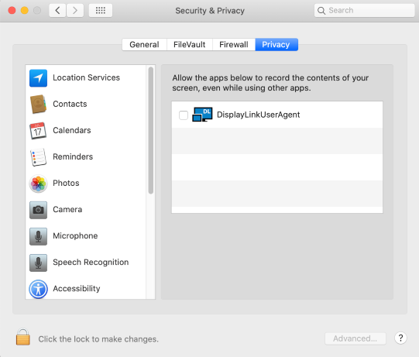

6. Click on the Lock to make changes.
7. Authenticate the changes by using your login details.
8. Check the box next to DisplayLinkUserAgent.
9. Click on the Lock again to save changes.

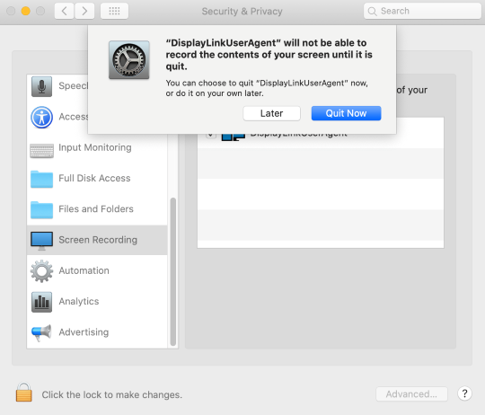
10. Click “Quit now”.
11. A reboot may be necessary with an older version of our driver.

