macOS Big Sur 11: Screen Recording permission
Since macOS Catalina system requires the user to permit "Screen Recording" for DisplayLink driver to work properly. Approving it enables the DisplayLink to access the pixels it needs to render a mirrored or extended screen and send the pixels over USB from your computer to the DisplayLink display. It does not send any data or pixels back to DisplayLink.
1. Download and install the latest DisplayLink Mac OS release for 10.15.
2. Reboot your system.
User is notified about a need for Screen Recording permission in three places.
- By macOS dialog box on first DisplayLink device plug-in: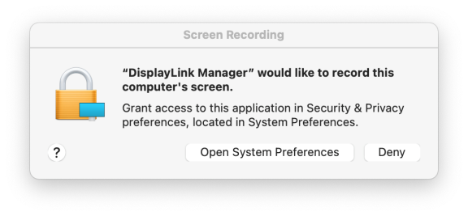
- By DisplayLink driver on each device plug-in:
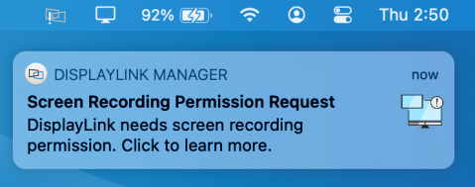
- By DisplayLink Manager app warning in macOS status bar:
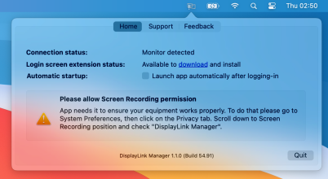
To approve the permission, please follow these steps:
3. Open System Preferences
4. Go to Security & Privacy
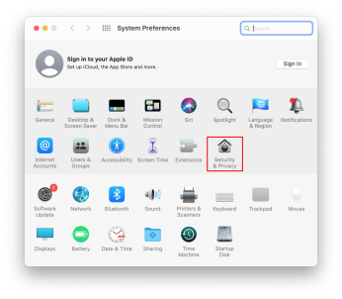
5. Go to Privacy.
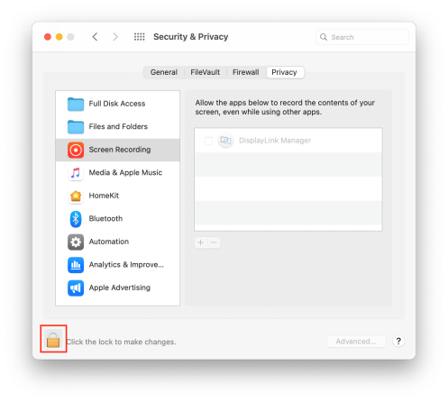
6. Click on the Lock to make changes
7. Authenticate the changes by using your login details.
8. Check the box next to DisplayLink Manager
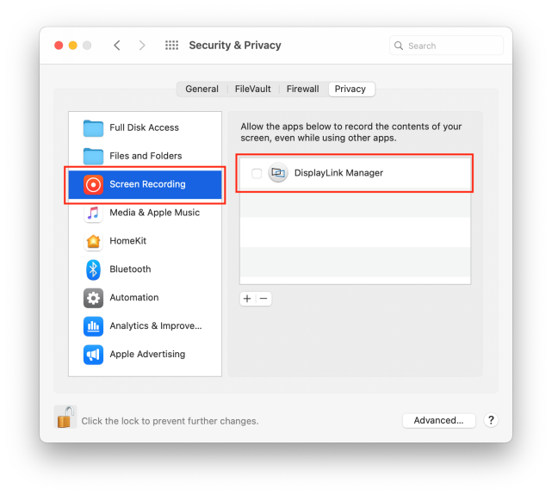
9. Click “Quit & Reopen”
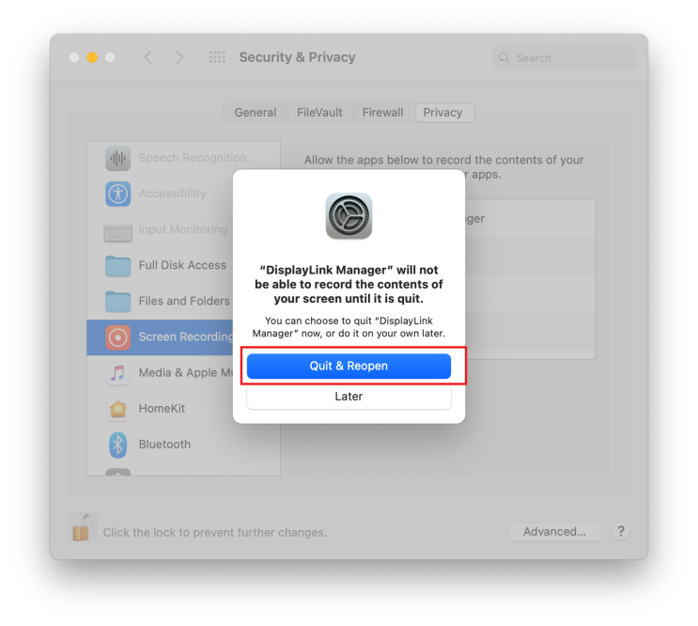
10. Click on the Lock again to save changes

